**Reading DICOM Image in Python-**

**Installing DICOM-**

* download the source code from the [Downloads tab](http://code.google.com/p/pydicom/downloads/list) .(Second file in the Screenshot)
* at a command line, change to the directory with the setup.py file
* with admin privileges, run python setup.py install

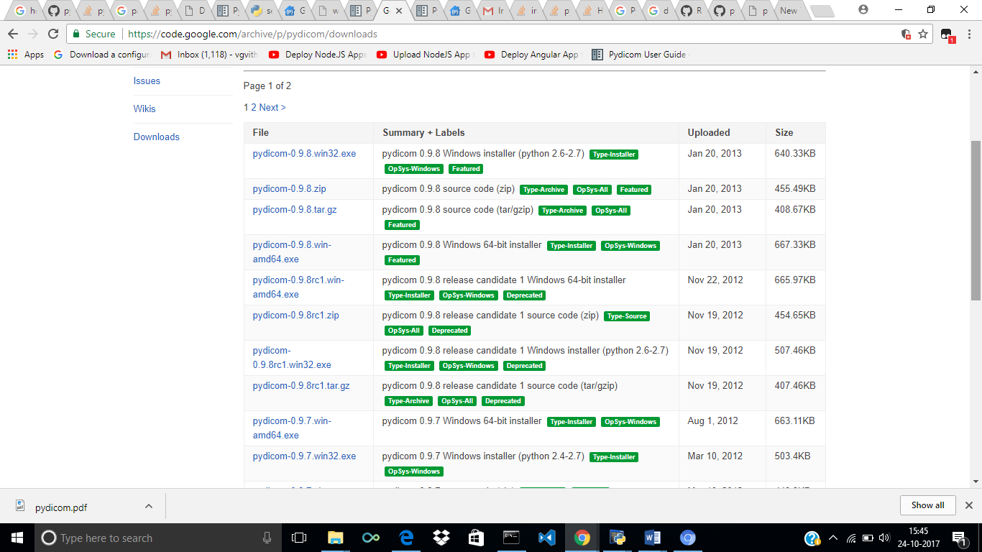

**Firstly download the image ( in DCM format)and then place it inside a folder**

**Step 1:-**

>>> import dicom

**Step 2:-**

>>> import pylab

**Step 3:-**

>>> ds=dicom.read_file(‘C:/testfiles/MR_small.dcm','br') //Reading the file

**Step 4:-**

>>> pylab.imshow(ds.pixel_array,cmap=pylab.cm.bone)

// It can take 2-d image information from ds.pixel_array and display it.

<matplotlib.image.AxesImage object at 0x0000000008CB6D68>

**Step 5:-**

>>>pylab.show()

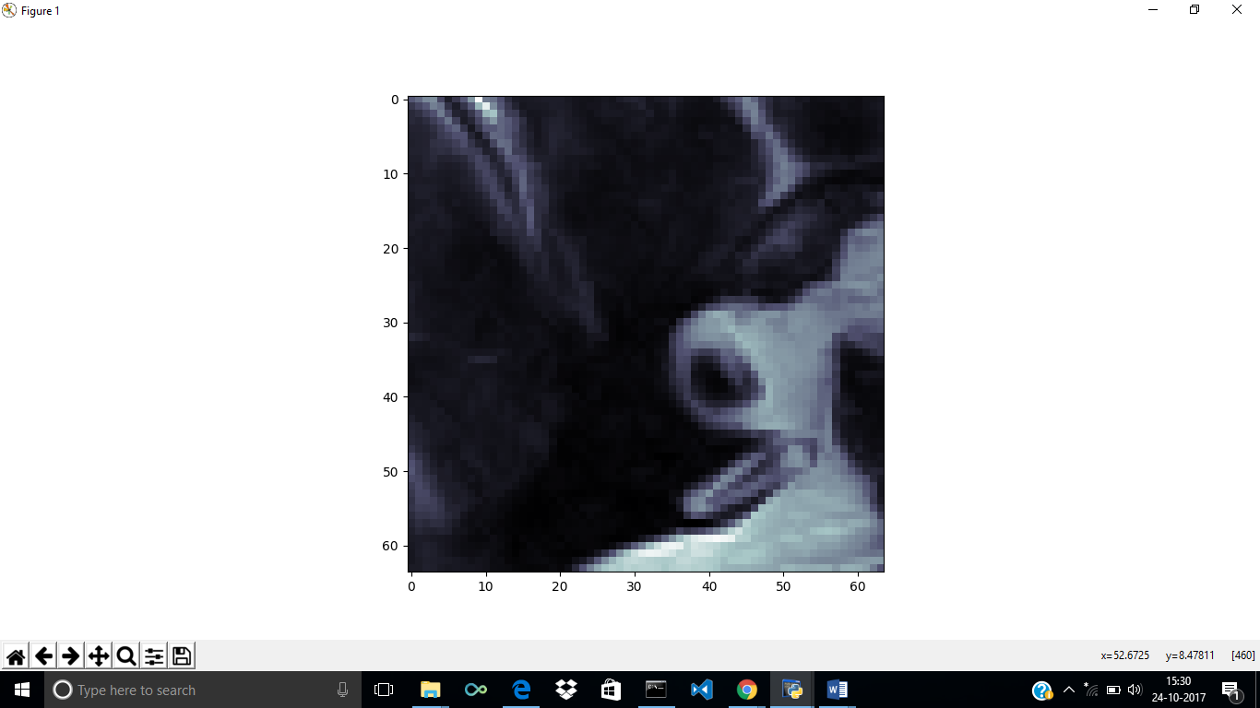

***Another Example-***

**Step 1:-**

>>> import dicom

**Step 2:-**

>>> import pylab

**Step 3**

>>>ds=dicom.read_file('C:/testfiles/aa.dcm','br')

**Step 4**

>>> pylab.imshow(ds.pixel_array, cmap=pylab.cm.bone)

<matplotlib.image.AxesImage object at 0x0000000009130C50>

**Step 5**

>>> pylab.show()

